1. Select Your Operating System (OS)  
     
   To begin, you need to head to the official [Microsoft 11 download page](https://www.ghacks.net/windows-11-upgrade-vs-clean-install-heres-the-difference/) for the **installation** assistant. You will see many options to [install Windows 11](https://en.softonic.com/articles/exciting-features-coming-windows-11); however you need to click on installation **assistant**. Once the file is downloaded, you can click the exe file to install it. Please note that in some cases, the installation assistant may ask you to download the PC health check app to [check your system's compatibility](https://www.ghacks.net/how-to-uninstall-a-windows-11-update/) with Windows 11.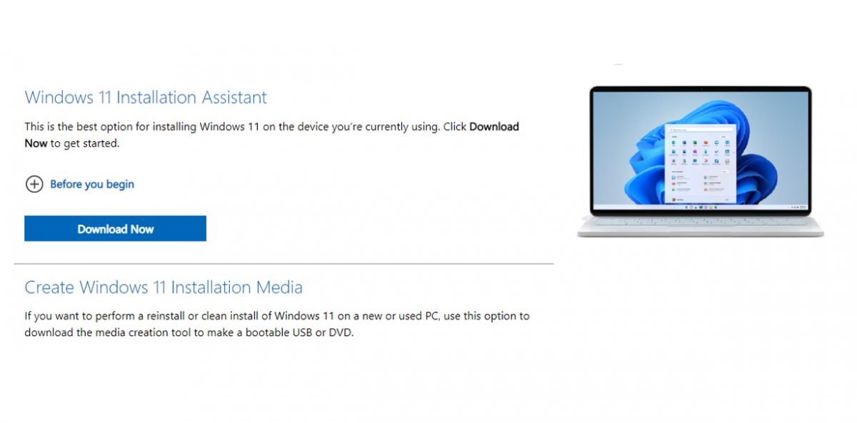

* **Downloading and Installing**  **Visual Studio Code**.**:** After clicking the link ( <https://code.visualstudio.com/Download>) I saw directed to a webpage that looks like this;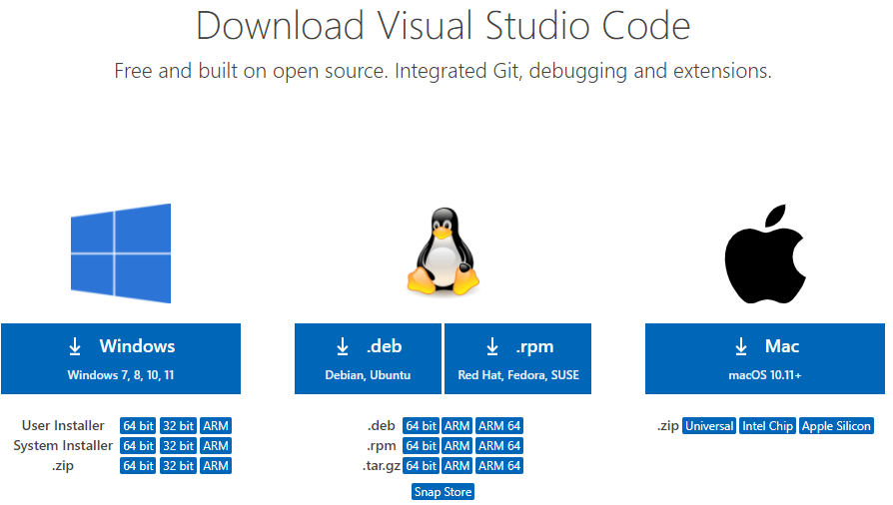  
  I then clicked the Download Icon on for the Windows version considering I’m using window.  
    
  3. **Set Up Version Control System: Installing and configuring Github**  
  When I clicked on the link ([https://github.com](https://github.com/)) I was directed to this website;A screenshot of a black screen

  Description automatically generated
* Considering I’ve already created my account and configured my environment for proper working. So I then went on to create “my first commit”.
* First I created a new “Repository”
* 
* I clicked on the “New” Icon that was at the top of the page
* 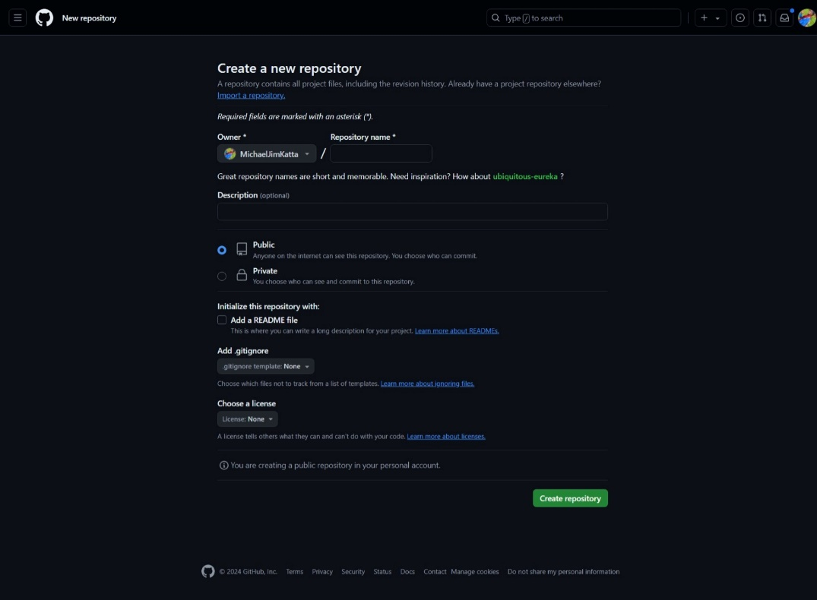
* I was then directed to this page aboveA screenshot of a computer

  Description automatically generated
* I filled in the information required
* 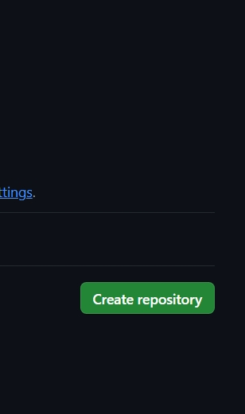
* Then I clicked “Create repository”
* I was directed to this page below.

* Now to create my first commit.
* I clicked on the “Edit” Icon
* A screen shot of a phone

  Description automatically generated
* I then add what I wanted to add to the file
* 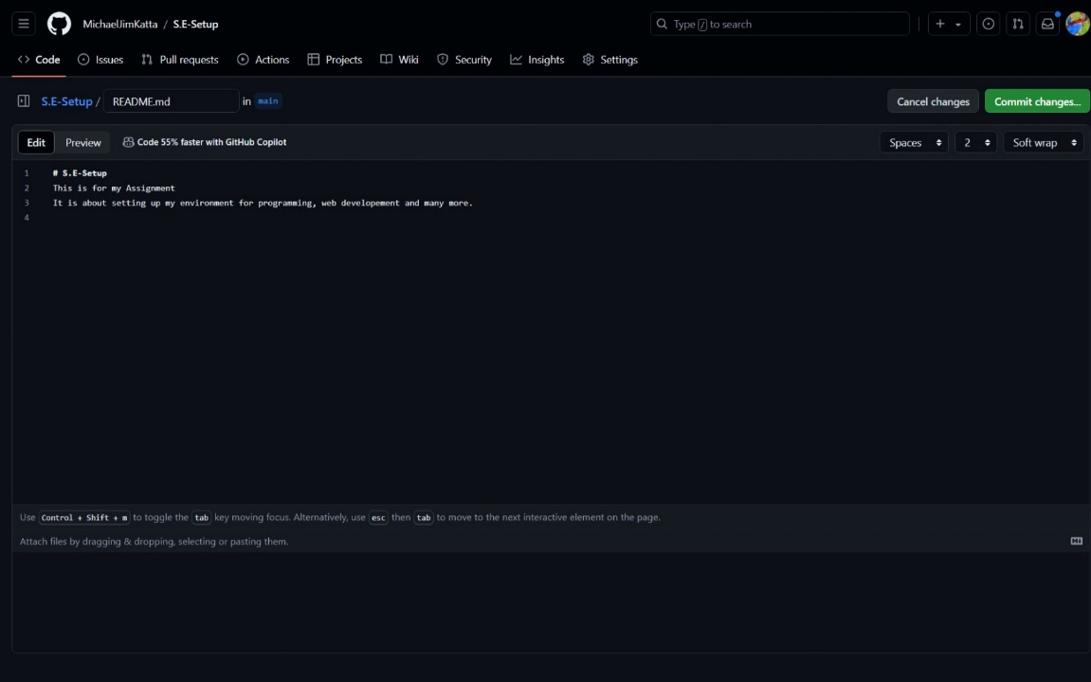
* When I was done editing I clicked on “commit changes”
* 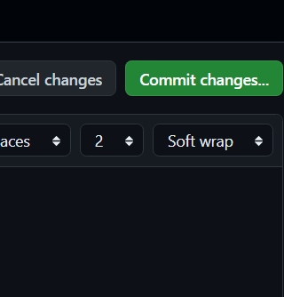
* This page popped up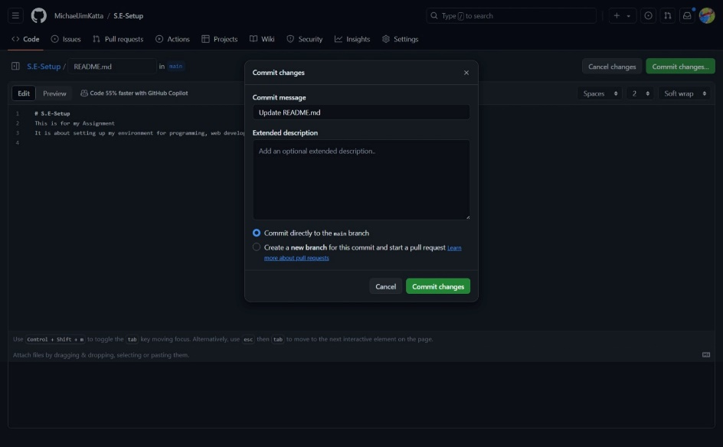
* Finally, A screenshot of a computer

  Description automatically generatedI committed my changes.

4**. Install Necessary Programming Languages and Runtimes**:

* For this section I will install python.
* So when I clicked on the link( <http://wwww.python.org>) I was directed to this page 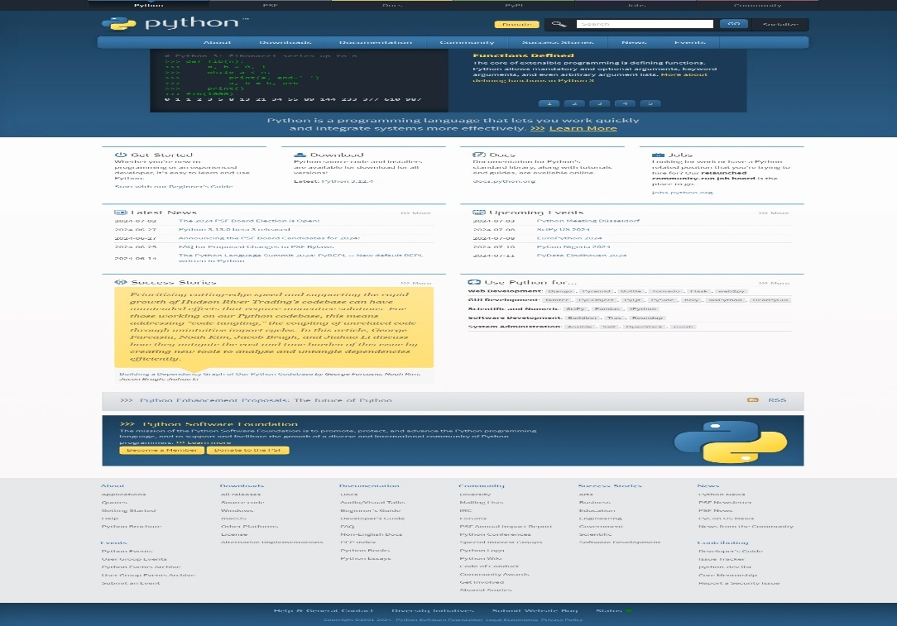
* I then clicked “Download”  
  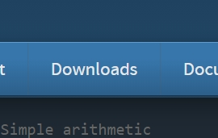
* After it had been downloaded, to check if it was in my local pc, I opened gitbash, typed the command “Python --version” then it showed me the version I had.

5**. Install Package Managers: installing “pip”.**

* In order to install “pip” you must have installed “git”.
* After installing git, you then try to download pip.
* To install “pip”, use the command “Python -m pip install pip”.
* After installing ‘Pip’ you continue with your project.

1. **Configure a Database (MySQL): Download and install MySQL database.**

* When I clicked on the link (<https://dev.mysql.com/downloads/windows/installer/5.7.html>) I was directed to this page;
* 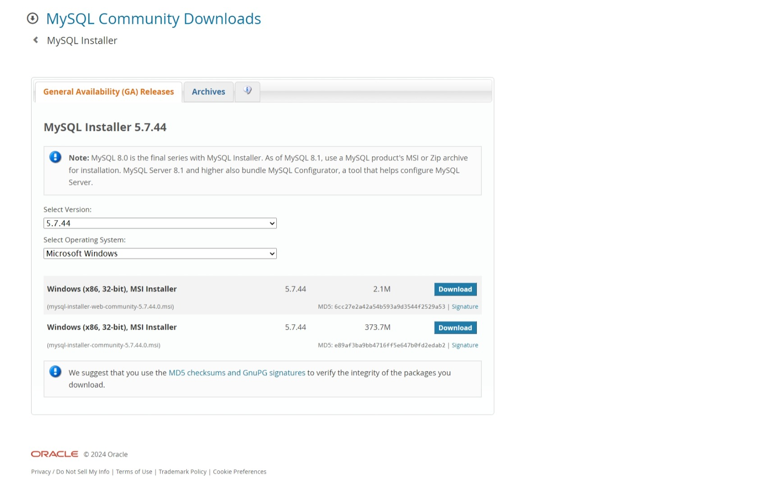
* Make sure to select your Operating System (OS)
* After double-checking your OS, you can then click download

1. **Set Up Development Environments and Virtualization**

* **Download Docker Desktop**:
  + Visit the [Docker website](https://docs.docker.com/desktop/install/windows-install/) and download the latest version of Docker Desktop for Windows.
  + Run the installer and follow the on-screen instructions.
* **Enable WSL 2**:
  + Ensure you have Windows Subsystem for Linux (WSL) enabled. If not, follow the Microsoft documentation to set it up.
  + Docker Desktop requires WSL 2 as the backend.
* **System Requirements**:
  + Your Windows 11 version should be Home or Pro 21H2 (build 19044) or higher, or Enterprise/Education 21H2 (build 19044) or higher.
  + You’ll need a 64-bit processor with Second Level Address Translation (SLAT) and at least 4GB of system RAM.
  + Make sure hardware virtualization is enabled in your BIOS.
* **Run Docker Desktop**:
  + After installation, launch Docker Desktop.
  + Explore its features, such as searching for images,
* I used this (<https://th.bing.com/th?&id=OVP.WPpmnC97FJ7U5lpBLsQ4pgEsDh&w=320&h=180&c=7&pid=1.7&rs=1>) walkthrough video.
* Setting up Virtual Machines
* **Check System Support**:
  + Ensure your computer’s hardware supports virtualization. Most modern CPUs do, but you may need to enable virtualization in the BIOS settings.
  + Verify that you have enough RAM and disk space for the VMs you plan to create.
* **Install a Hypervisor**:
  + A hypervisor is software that manages VMs. Common choices include:
    - **Hyper-V (Windows)**: Built into Windows 10/11 Pro, Enterprise, and Education editions.
    - **VirtualBox**: A free, open-source option available for Windows, macOS, and Linux.
    - **VMware Workstation**: A paid solution with advanced features.
    - **KVM/QEMU**: Popular on Linux systems.
* **Create Your VM**:
  + Open your chosen hypervisor (e.g., Hyper-V Manager or VirtualBox).
  + Use the wizard to create a new VM:
    - Specify a name for the VM.
    - Choose a location to store VM files.
    - Select the VM generation (usually Generation 2 for 64-bit OS).
    - Allocate memory (RAM) and configure networking.
    - Create a virtual hard drive (VHD or VDI) for storage.
    - Install an operating system from an ISO file (e.g., Windows, Linux).
* **Run Basic Operations**:
  + Start the VM and install the OS.
  + Adjust VM settings (CPU cores, memory, etc.).
  + Use snapshots to save VM states for easy rollback.
  + Explore features like shared folders, clipboard integration, and networking.

1. Explored Extensions and plugins:

**Visual Studio Code (VS Code)**:

* **Extensions**: VS Code has a rich ecosystem of extensions. Some essential ones include:
  + **ESLint**: For JavaScript/TypeScript linting.
  + **Prettier**: For code formatting.
  + **GitLens**: Enhances Git integration.
  + **Live Server**: For live preview of web pages.
  + **Python**: If you’re working with Python.